Celebal Summer Internship 2026

Week 5 : Spark Fundamentals, Data Cleaning, and Core Transformations

Submitted by : Shauryansh chauhan (MMDU)
Roll no .:11232836
Course: B.Tech Computer Science & Engineering
Assignment of week 5

Q1: What are the key limitations of traditional MapReduce that make Spark a preferred choice for modern big data processing?

Ans:
Traditional Hadoop MapReduce has several processing bottlenecks that led to the development of Apache Spark:
1. Disk-Bound Overhead: MapReduce strictly forces intermediate results to write directly to physical storage (HDFS) between every single Map and Reduce phase. This causes severe disk I/O bottlenecks and intensive network serialization.
2. High Initialization Latency: MapReduce launches a separate Java Virtual Machine (JVM) instance for every specific task it processes, creating massive startup overhead. Conversely, Spark maintains a long-lived multi-threaded executor architecture.
3. Rigid Linear Design: Applications must conform to an explicit sequence of linear Map and Reduce steps, which translates poorly to multi-step pipelines or complex graph-based data processing architectures.

Q2: Explain how Spark uses In-Memory Computing to speed up iterative machine learning algorithms compared to disk-based systems.

Ans: Iterative algorithms (such as K-Means clustering, PageRank, or Gradient Descent optimization) access the exact same dataset repeatedly across dozens of mathematical sweeps. In traditional disk-based systems, every single iteration requires fetching data from the physical disk layer and saving the output right back to it.
Apache Spark mitigates this by allowing developers to explicitly pull data partitions into the worker node's RAM using standard caching operators like .cache() or .persist(). Once the data is cached in memory, all subsequent algorithmic processing loops query memory directly. This skips all underlying physical disk input/output cycles, accelerating calculation workloads by up to 100 times.

Q3: Write a code snippet to remove all duplicate rows from a DataFrame based on a specific set of columns: user_id and transaction_date.
Ans:
df_cleaned_dupes =df.dropDuplicates(["user_id", "transaction_date"])
display(df_cleaned_dupes)

OUTPUT:
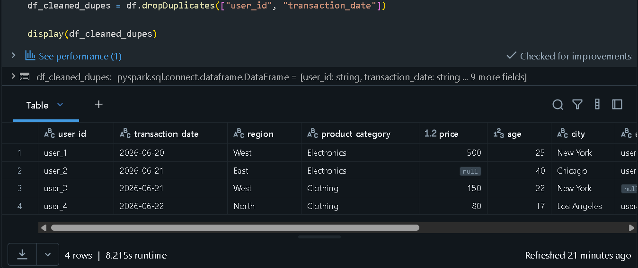

Q4: Given a DataFrame df_sales, write a query to filter for rows where the region is 'West' and then group by product_category to find the average sale_amount.
Ans:
west_data = df_sales.filter(F.col("region") == "West")
avg_sales = west_data.groupBy("product_category").agg(F.avg("price").alias("avg_sale_amount"))
display(avg_sales)
OUTPUT:

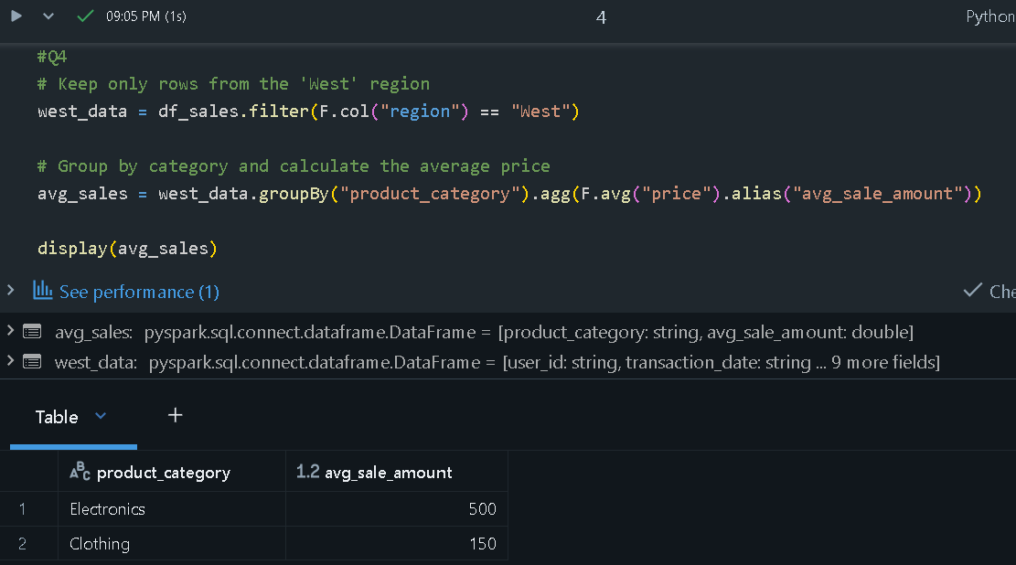

Q5: What is the difference between .na.drop() and .na.fill()? Provide a code example of filling null values in a status column with the string 'Unknown'.
Ans:
df_filled_status = df.na.fill({"username": "Unknown"})
display(df_filled_status)

OUTPUT:
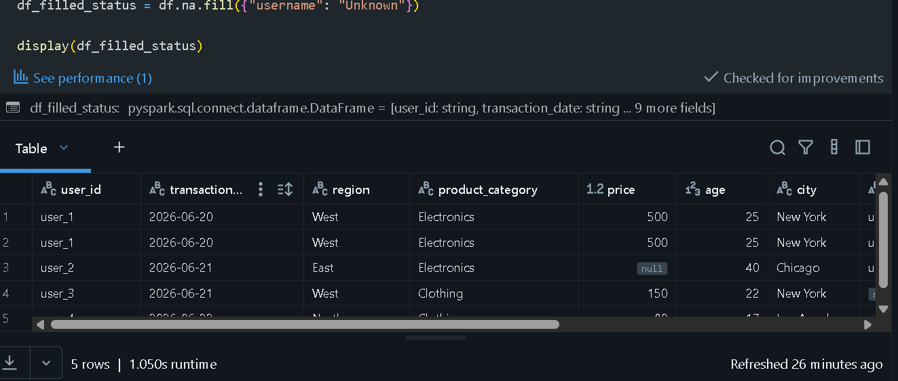

Q6: Write a query to find the total count of records for each city in a DataFrame, but only for cities where the count is greater than 100.
Ans:
city_counts = df.groupBy("city").count()
large_cities = city_counts.filter(F.col("count") > 100)
display(large_cities)

Q7: How does the immutability of Spark DataFrames affect how you perform "data cleaning" steps like dropping columns or renaming them?
Ans:
Spark DataFrames are strictly immutable—they cannot be physically modified after creation. When cleaning datasets (e.g., dropping or renaming target columns), Spark never applies updates in place to the underlying memory structure. Instead, it processes your instruction to create a completely new DataFrame wrapper that points to an updated execution schema.
This foundational design works together with Lazy Evaluation. Rather than computing results immediately for every cleaning step, Spark appends these changes onto a continuous lineage track (a Directed Acyclic Graph or DAG). The operations are optimized and physically executed only when a terminal action (such as .show(), .count(), or data writes) is requested.

Q8: Write a Spark command to filter a dataset for rows where the age is between 18 and 30 (inclusive) and the subscription is 'Premium'.
Ans:
age_filter = F.col("age").between(18, 30)
premium_filter = F.col("region") == "West"
df_filtered_users = df.filter(age_filter & premium_filter)
display(df_filtered_users)
OUTPUT:
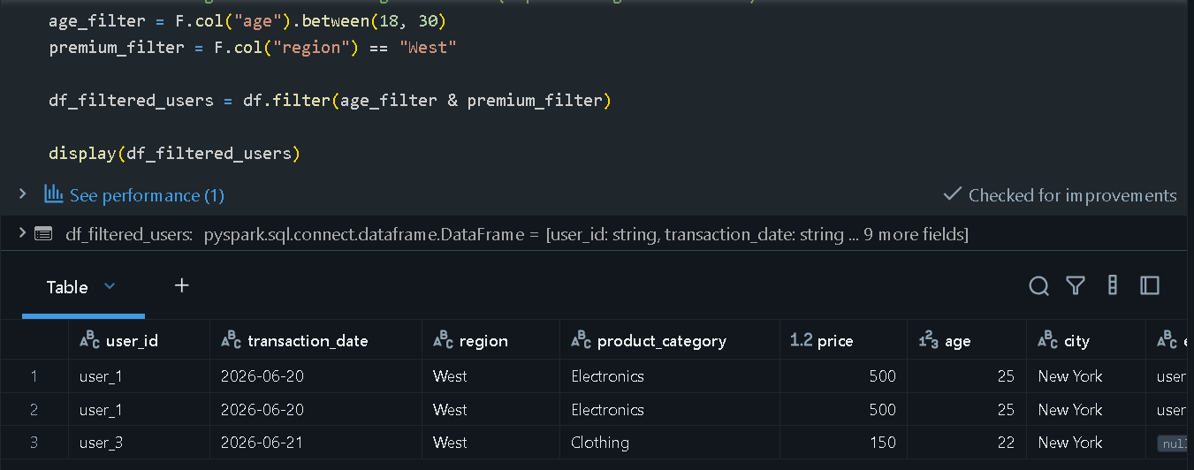

Q9: When cleaning a dataset, why is it often better to handle null values before performing mathematical aggregations like sum() or avg()?
Ans:

Handling missing or null values before executing complex mathematical summaries is necessary due to two primary data risks:
1. Mathematical Skew: Aggregations like avg() or mean() omit null markers entirely. If your columns contain unexpected null rows, the total denominator changes, generating skewed or unrepresentative figures.
2. Arithmetic Erasure: If mathematical operations are performed across multiple columns (such as price + tax), any column containing a null will cause the entire expression's row calculation to resolve as null, wiping out otherwise valid data rows.

Q10: Write the code to revise a column named raw_timestamp by casting it to a TimestampType and renaming it to event_time.
Ans:
df_with_time = df.withColumn("event_time", F.col("raw_timestamp").cast(TimestampType()))
df_final_time = df_with_time.drop("raw_timestamp")
display(df_final_time)
OUTPUT:
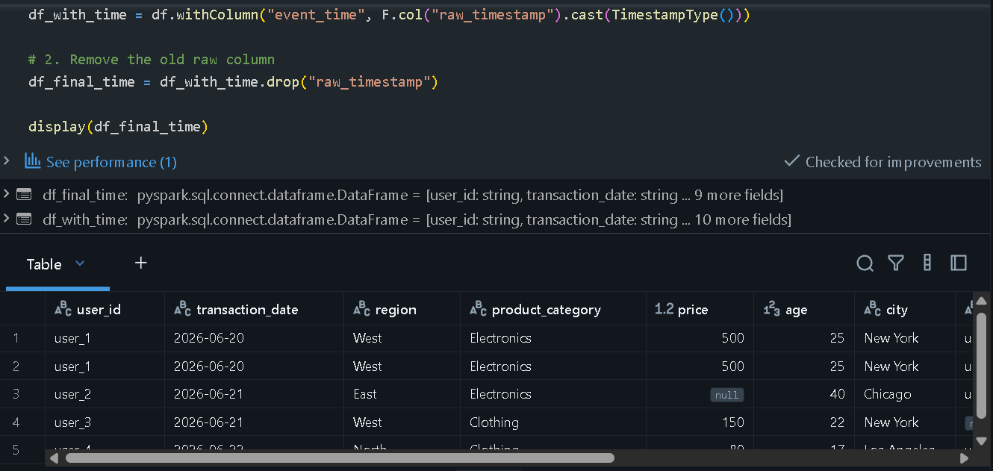

Q11: Explain the "Shuffle" process that occurs during a grouping operation. Why is it considered a wide transformation?
Ans:
A Shuffle represents the physical restructuring and network transfer of data records across different physical cluster partitions. In an operation like groupBy('city'), individual transactions containing identical city tags will initially reside across multiple worker nodes.
To compute an aggregation, Spark must execute a many-to-many data redistribution, transferring matching data keys onto the exact same partition. Shufflings are categorized as Wide Transformations because a target data partition relies on processing inputs from multiple source nodes across the cluster. This is generally the most resource-intensive phase in a Spark workload.

Q12: Write a code snippet that identifies and removes rows where the email column contains null values OR the username is an empty string.
Ans:
good_email = F.col("email").isNotNull()
good_username = F.col("username") != ""
df_valid_rows = df.filter(good_email & good_username)
display(df_valid_rows)
OUTPUT:
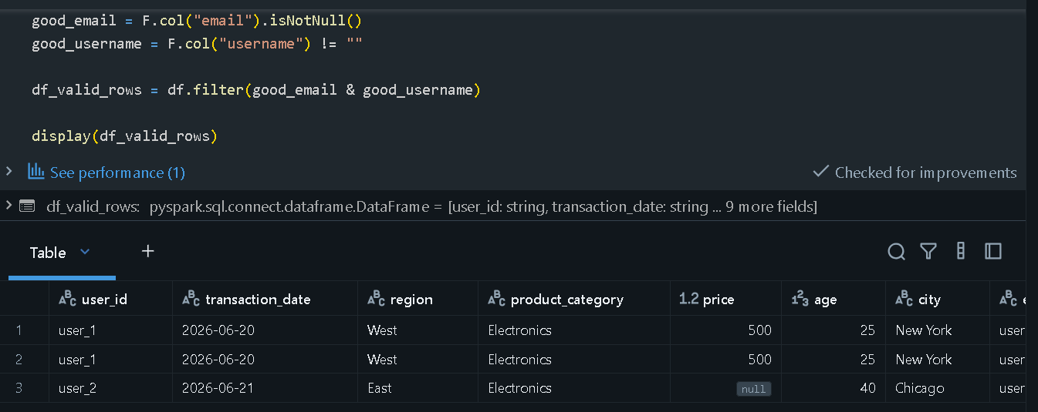

Q13: How do you use the .agg() function to calculate multiple statistics at once, such as the min, max, and mean of the price column?
Ans: price_stats = df.agg(
F.min("price").alias("min_price"),
F.max("price").alias("max_price"),
F.mean("price").alias("avg_price")
)
display(price_stats)
OUTPUT:

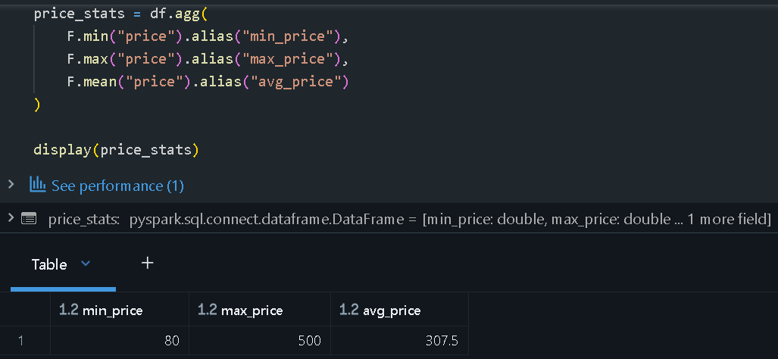
Q14: In the context of cleaning a dataset, what is the risk of using inferSchema=true when your source data contains messy or inconsistent date formats?
Ans:

Enabling inferSchema=true forces the Spark processing engine to sample a subset of rows from source files to guess column data types. When handling messy date strings (e.g., mixing ISO format '2026-06-21', European format '21/06/2026', and text values like 'N/A'), Spark will fail to resolve the column into a uniform temporal type.
As a result, Spark falls back to interpreting the entire column as a standard StringType. This hides underlying formatting issues and causes downstream calculations to break or resolve as null when executing formal datetime operations.

Q15: Write a final processing pipeline that:
- Filters out duplicates.
- Fills null prices with 0.
- Groups by store_id to calculate total revenue
Ans:
def clean_and_calculate_revenue(input_df):
no_duplicates = input_df.dropDuplicates()
fixed_prices = no_duplicates.na.fill({"price": 0.0})
store_revenue = fixed_prices.groupBy("store_id").agg(F.sum("price").alias("total_revenue"))
return store_revenue
pipeline_results = clean_and_calculate_revenue(df)
display(pipeline_results)
